
Symbiosis Institute of Technology, Pune
CSE- Academic Year 2026-27
Java Programming – Lab Batch 2025-29
Lab Assignment No.:
Name of Student | Akshit Gawade
PRN No. | 25070122029
Batch | 2025-2029
Class | A1
Academic Year & Semester | Second Year  Semester III
Date of Submission
Title of Assignment: | Write a Java program to create and use user-defined packages
Problem Statement  &  Learning Objective | Problem Statement  Write a Java program to create and use user-defined packages.  Learning Objectives  To create and use user-defined packages for organizing Java programs
Theory | Packages are used to organize related classes and interfaces into namespaces. User-defined packages improve code organization, reduce naming conflicts, and enhance reusability. They also support access protection and modular application development. Java packages simplify project management by grouping logically related components together. Large-scale software systems extensively use packages.
Program Code | import package1.MyClass;  public class Main {  public static void main (String[] args) {  MyClass obj = new MyClass();  obj.display();  }  }  MyClass.java:  package package1;  public class MyClass {  public void display () {  System.out.println("This is how a package works");  }  }
Output Screenshots | 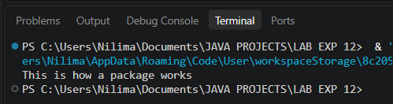
Exercise Qns  and Code | 1. Create a Java program by developing user-defined packages for a College Management System. Create separate packages for student and faculty details, and display their information using classes from these packages.  2. Create a Java program by developing a user-defined package named library that contains a class to store and display book details such as book ID, title, author, and price. Import the package into the main program and display the book information.
Output Screenshots | EXERCISE 1  Ex1.java  package Exercise.Ex1;  import Exercise.Ex1.student.Student;  import Exercise.Ex1.faculty.Faculty;  public class Ex1 {  public static void main(String[] args) {  Student s = new Student(101, "Akshit", "Computer Science and Engineering");  Faculty f = new Faculty(201, "Dr. Dutta", "CSE");  s.display();  f.display();  }  }  ----------------------------------------------------------------  Student.java  package Exercise.Ex1.student;  public class Student {  int id;  String name;  String course;  public Student(int id, String name, String course) {  this.id = id;  this.name = name;  this.course = course;  }  public void display() {  System.out.println("----- Student Details -----");  System.out.println("Student ID : " + id);  System.out.println("Name : " + name);  System.out.println("Course : " + course);  }  }  Faculty.java  package Exercise.Ex1.faculty;  public class Faculty {  int id;  String name;  String department;  public Faculty(int id, String name, String department) {  this.id = id;  this.name = name;  this.department = department;  }  public void display() {  System.out.println("\n----- Faculty Details -----");  System.out.println("Faculty ID : " + id);  System.out.println("Name : " + name);  System.out.println("Department : " + department);  }  }  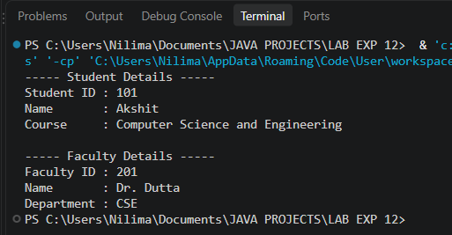  EXERCISE 2:  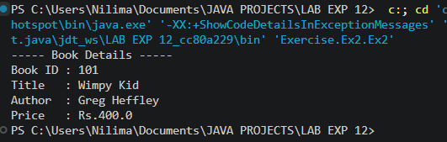  CODE:  BOOK.java:  package Exercise.Ex2.library;  public class Book {  int bookId;  String title;  String author;  double price;  public Book(int bookId, String title, String author, double price) {  this.bookId = bookId;  this.title = title;  this.author = author;  this.price = price;  }  public void display() {  System.out.println("----- Book Details -----");  System.out.println("Book ID : " + bookId);  System.out.println("Title : " + title);  System.out.println("Author : " + author);  System.out.println("Price : Rs." + price);  }  }  Ex2.java:  package Exercise.Ex2;  import Exercise.Ex2.library.Book;  public class Ex2 {  public static void main(String[] args) {  Book b = new Book(101, "Wimpy Kid", "Greg Heffley", 400.00);  b.display();  }  }
Conclusion | This experiment focuses on modular code organization and encapsulation through custom Java packages. By structuring classes into logical directory hierarchies, it illustrates how packages simplify namespace management, control accessibility, and streamline maintainability across large multi-component projects.

